**Out of Scope**

1. Building a mobile application
2. Remittances
3. Debit Card Transaction
4. Other Investments
5. Fixed Deposits
6. CRM
7. SMS notifications
8. Linking other Bank Accounts
9. No instant transfer of funds to other account.

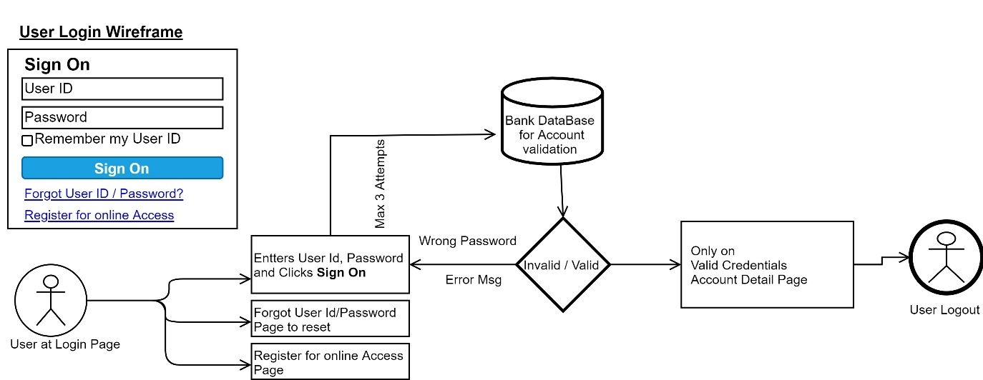**4.2 User Login**

|  |  |
| --- | --- |
| **Step #** | **Process** |
| 1.0 | User clicked on login button/link |
| 2.0 | Login Page is displayed |
| 3.0 | User enters User Id, Password and clicks Sign On button |
| 3.0.1 | System validation for correct credentials |
| 3.0.1.1 | If validation is passed, Account details page is displayed for further action. |
| 3.0.1.2 | If validation failed, user is on same login page with 2 more option (back to 3.0) with Msg. |
| 3.1 | Forgot User ID / Password? Link is clicked; Password maintenance page is opened. |
| 3.2 | Register for online Access; Link is clicked; Online Access Request page is opened. |

|  |  |  |
| --- | --- | --- |
| **Br #** | **Business Requirement** | **Priority** |
| BR 4.2.0 | Assumption: User is on Login Page. |  |
| BR 4.2.1 | 1. User has 2 input section both are required fields. Before clicking Sign On Button. 2. Two clickable links for Forgot User Id/ Password? & Register for online Access | High |
| BR 4.2.1.0 | User Clicks on Sign On Button | High |
| BR 4.2.1.0.1 | System Validation on Both fields enter,  If Failed Error Msg on Screen to enter User Id and/or Password  If Passed, will check for match in Server   1. If Matched: Account Details Page is opened. 2. If Unmatched: Fail Counter is activated for max 3 attempts   Error msg is flashed on screen to enter current credentials with available attempts. User is back to login page | High |
| BR 4.2.1.1 | User Clicked on Forgot User ID / Password? Link | Low |
| BR 4.2.1.2 | User Clicked on Register for online Access Link | Low |

**4.4. Funds Transfer**

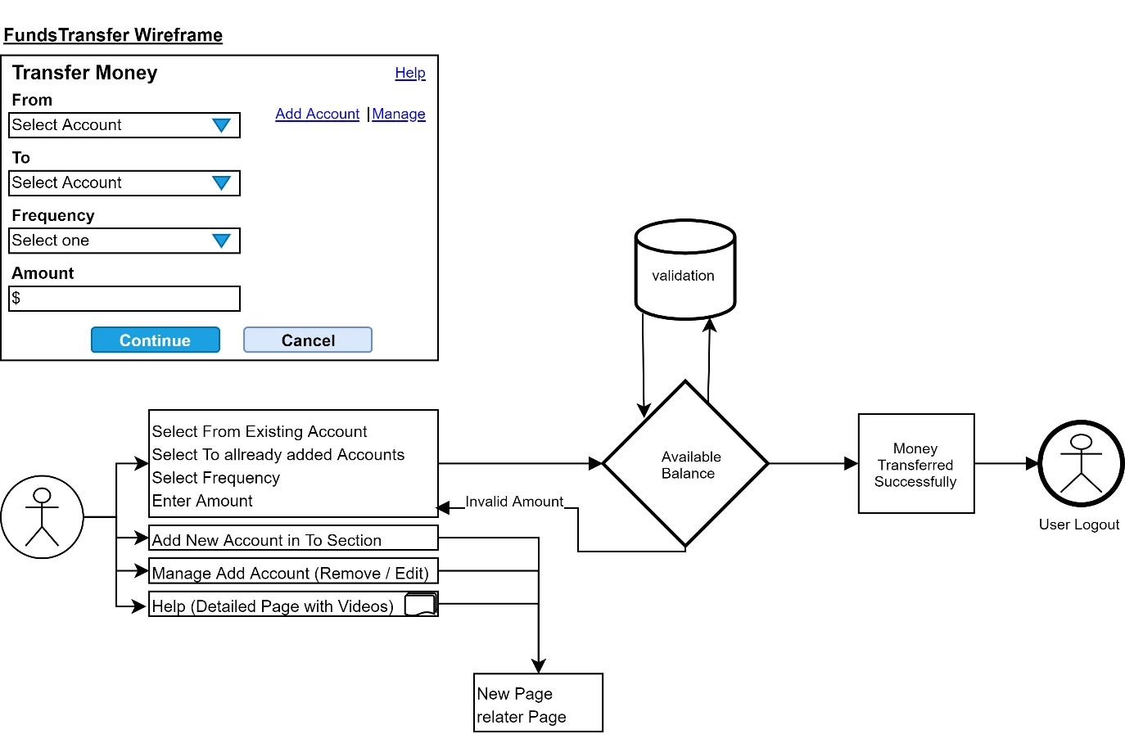

|  |  |
| --- | --- |
| **Step #** | **Process** |
| 1.0 | User clicked on Funds Transfer button/link |
| 2.0 | Fund Transfer Page is displayed |
| 3.0 | Select From available Account (Saving/Checking) |
| 3.1.0 | Data Capturing |
| 3.1.1 | Select To added Account |
| 3.1.2 | Select Transfer Frequency |
| 3.1.3.0 | Enter Transfer Amount. (Force User to enter only numbers, No Blank Cell) |
| 3.2 | Cancel Button: Back to Account Detail Page |
| 3.3.0 | Continue Button: Validation for all fields selected / Entered |
| 3.3.0.0 | Check Available Balance and Condition set by Bank on Minimum Balance |
| 3.3.0.1 | If Passed Execute Transfer and Flash Msg “Transfer Successful” |
| 3.3.0.2 | If Failed, Back to Fund Transfer Page and Flash Msg with appropriate msg. |
| 3.4 | Add Account link: On clicks open Add Account Page. |
| 3.5 | Manage Link: Account Manage page to edit or delete fund transfer Accounts. |

|  |  |  |
| --- | --- | --- |
| **Br #** | **Business Requirement** | **Priority** |
| BR 4.4.0 | Assumption: User is on Fund Transfer Page. |  |
| BR 4.4.1.0 | Data Selection and Entry Fields (From, to Frequency and Amount) | High |
| BR 4.4.1.1 | Force User to enter Proper Amount format | High |
| BR 4.4.2.0 | After selecting and entering all details continue button is activate and allowed to click | Low |
| BR 4.4.2.1 | On clicking on the continue button, System validates the fund available in selected account and Bank conditions. Upon success full, funds are transferred and user gets a transfer successful msg. | High |
| BR 4.4.2.2 | Upon Failure, user gets a msg of available amount for transfer and is back to same page. For further action | Low |
| BR 4.4.3 | Cancel Button: on clicking on the cancel button, user is taken back to previous page or account page as per banks policy | High |
| BR 4.4.4 | Help Link, this is Fund Transfer library, explaining user on how to use system and its safety provisions. | Low |
| BR 4.4.5 | Add Account Link: this link should open a page for user to add more Account details where he wishes to transfer funds. | Low |
| BR 4.4.6 | Manage Link: This link should open page where existing account is added for editing account details or deleting added account | Low |

**6.    Non- Functional requirements**

**Usability:** System should be easy to learn and navigate, help with video should be available but, system should be easy to use. Few task on the screen.

**Security:** How are the system and its data protected against attacks? Back up in case of system failure.

**Performance**: How fast system would response and return the necessary results. Then there is heavy traffic on the website, can the capacity be increased? Response time should be in nano seconds.

**7.    Assumptions**

1. The User shall have access to Internet.
2. The User shall have computer/laptop/smartphone which has a browser.
3. The User shall have knowledge of internet navigation.
4. The user should be active on the site to avoid timeout.
5. Cookies are turned on for this site.
6. Popup Blockers to be turned off.
7. In Approved list of Anti-Virus software.